Improved Process and Data Collection
Dante Dionne
University of Phoenix
MGT 449: Quality Management & Productivity
Group GA01BSM09C
Instructor: James Eyster, MBA.

August 19, 2003

Introduction
The following paper is an Improved Process and Data Collection plan prepared on the Sportsteller Corporation. Included are flow-charts and descriptions of the improved processes, items that have been measured to substantiate the improved process and the data required to measure improvement and ensure a continuous monitoring process.
Additional discussion is made on the relationship of the process to the Sportsteller Corporation's strategic plan. Researched items include the internal and external customers of the Sportsteller Corporation organization, available reports and the corporate web site.
Background
Sportsteller Game Consultants, LLC (Sportsteller), is a newly established domestic gaming and entertainment Company that specializes in developing, producing, and marketing sports handicapping analysis and information via the Internet (www.sportsteller.com), and soon to be released via 900 answering services (900-SGC-PICK).
The goal at Sportsteller is to deliver gaming expertise and financial money management programs that produce greater profits than mutual funds, the DOW or even real estate. Bettors can easily log on to the website and/or call the sales team for information and betting advice without leaving the comfort of their own home (Sportsteller, 2002).
Quality Improvement Overview
During the month of July 2003, usability testing of the Sportsteller corporation website re-design was conducted with both internal and external customers in mind. The purpose of this study was to identify potential usability issues with the newly redesigned website and to determine users’ levels of satisfaction with the system.
Focus group participants performed thirteen distinct tasks during a 60-minute session. The majority of problems that users had encountered were as a result of inconsistencies in the visibility of system status. While all participants mentioned that the pull down navigation menus (see Figure 5-A) were a “great” feature, they all exhibited problems navigating within sub–pages of the site.
All users expressed the desire to click on the side navigation buttons (See Figure 6-A.) that had been disabled rather than use the navigational buttons on the upper portion of the page. In addition to general navigation challenges, three users commented on the amount and presentation of information. The tasks of determining the benefits to the separate membership options proved to be the most difficult for users. Three of the users commented several times that they thought there was too much information and text making it undesirable to read, while another user commented that there needed to be more detailed information.
Despite the difficulties users had with the system, all of the participants expressed a high level of satisfaction with the system. Responses to a post-test satisfaction questionnaire revealed that users for the most part liked the website navigation, information architecture, and visual design. Yet despite the high satisfaction ratings, there were several negative features of the website that inhibited their navigation and information retrieval. Observations were made of a number of aspects of the interface that were independent of the design treatment and several recommendations are provided which have been incorporated into the next design iteration.
Data Collection
The purpose of this usability study was to identify the strengths and weakness of the prototype Sportsteller corporate website from an authentic user’s perspective. Data gathered from this usability session will be directly used in the prototype development prior to its delivery to the client.
In late May, the Sportsteller marketing team made recommendations for a website redesign with an entirely new look and feel. They specifically asked for a professional, clean, customer website that was easy to navigate. After consulting with the marketing team and receiving images and text for the site, the design team began the website redesign.
An important note: The business teams had specifically asked us to include a redesign of the collaboration (See Figure 1-A.) and Finance (See Figure 2-A.) business systems to support the strategic direction recently mandated by the company. This would include graphically modeling the business solutions as seen in its current state and mapping the business requirements to an interim and strategic solution.
The major elements of the redesign are as follows: 1) Clear, visible navigation, 2) Quick downloading time for modem users, 3) Logical labeling and information location and 4) Information chunking.
By observing the users and through the use of the think out loud protocol, we identified several usability issues in the design of the site. These were also reflected in the satisfaction data. The observations and interpretations of them are listed in the tables below, together with the recommendations for correcting the problems. These recommendations have been incorporated into the final site design. Two main issues were most prevalent among the users were 1) Navigation System Consistency and 2) Visibility of Status.
The Sportsteller website is not perceived to be poorly designed, however, it is felt that some modifications could be made to enhance the users experience (See Figure 3-A.). Overall, the use of unnecessary items on an entrance screen would be the main objection. Unnecessary items include the site navigation object and the overall layout. Eliminating them and placing them elsewhere, would benefit the site as a whole. Creating a separate navigation system would help to overcome this problem. This can be backed with the idea of organization and simplification.
Utilizing a quality framework for a self-evaluation is demonstrative of an organization's commitment to a systematic improvement approach. At the first Strategy Forum, a “Collaborative Goal Setting Workshop” was used to provide a baseline for recognizing future improvement opportunities and for setting organizational stretch targets (Pearson, 2003).
Key Areas of the Program
Reengineering efforts have “swept the country as companies pursue the promise of dramatically improved quality, service, productivity and profitability” (Pearson, 2003). The most significant effect of this reengineering revolution is the “awareness of process it generated for managers in all industries” (Pearson, 2003).
Any organization can be broken down into a “collection of processes” (Pearson, 2003). These processes are the “natural business activities performed that produce value, serve customers, and generate income” (Pearson, 2003). Managing these types of processes is the key to the success of the Sportsteller Corporation. “Process mapping” is the first step of process management (Pearson, 2003). It consists of tools that “enable a corporation to document, analyze, improve, streamline, and redesign the way your company performs work” (Pearson, 2003).
Armed with a thorough understanding of the inputs, outputs and interrelationships of each process, the Sportsteller Corporation can 1) Understand how processes interact in the overall business system, 2) Locate process flaws that are creating systemic problems, 3) Evaluate which activities add value for their customers, 4) Streamline and improve work flows, 5) Identify processes that need to be reengineered and 6) Improve efficiency and customer satisfaction.
Summary
The system map will be the first step to give direction and focus to a Sportsteller sanctioned quality improvement effort. It will build out from existing processes to identify suppliers, inputs, outputs, customers, expectations, performance gaps, and feedback loops.
The exercise of producing a web system map (see Figure 3-A) has helped to clarify objectives and measures for the improvement and reengineering initiative. It is intended to frame the perspective toward process analysis, at either the macro or micro level. This horizontal user function / process depicted in Figure 4-A, crosses the departmental boundaries of sales, order processing, distribution, billing, and perhaps even manufacturing. By optimizing performance across the process, huge gains are possible.

Reference
University of Phoenix (Ed.). (2003). Quality management and productivity [University of Phoenix Custom Edition e-text]. Upper Saddle River, NJ: Pearson Custom Publishing.
Dionne, D. (2002). Sportsteller, Inc. Business Plan Retrieved July 30, 2003 from www.sportsteller.com.

Figure 1-A.

“Company” – Sportsteller Strategic Collaboration Process
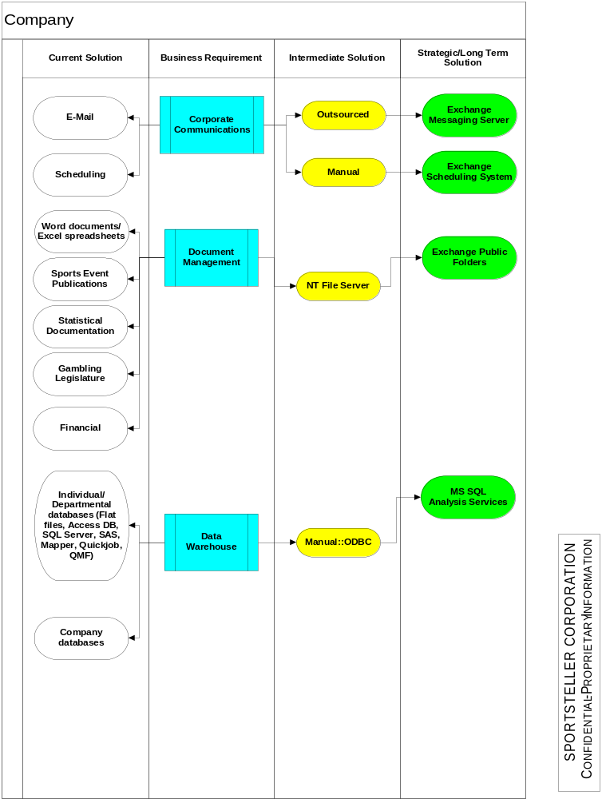

Figure 2-A.

“Finance” – Sportsteller Strategic Financial Process

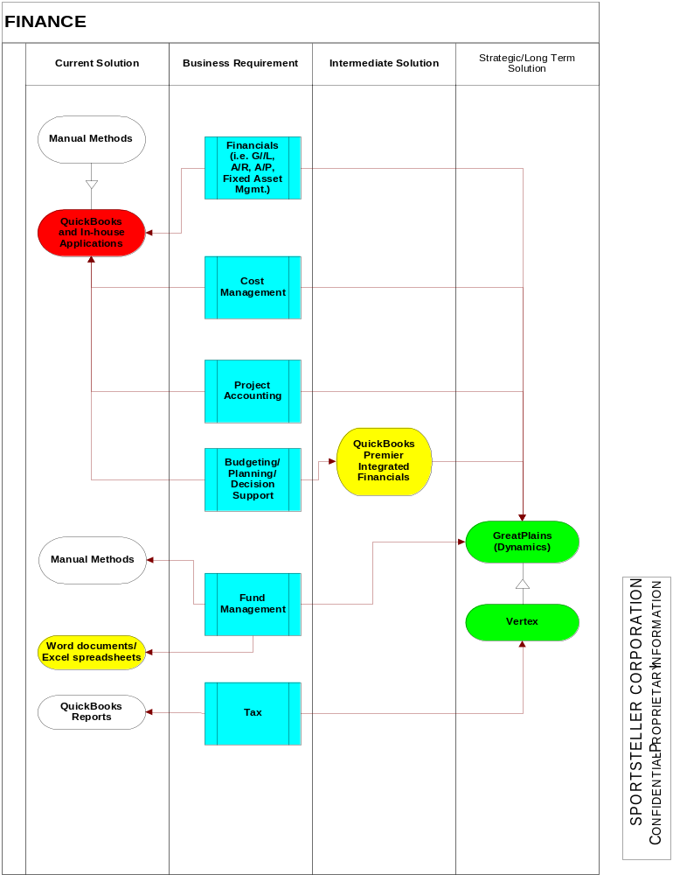

Figure 3-A.

“Could Be” – Sportsteller Corporate Website Flow
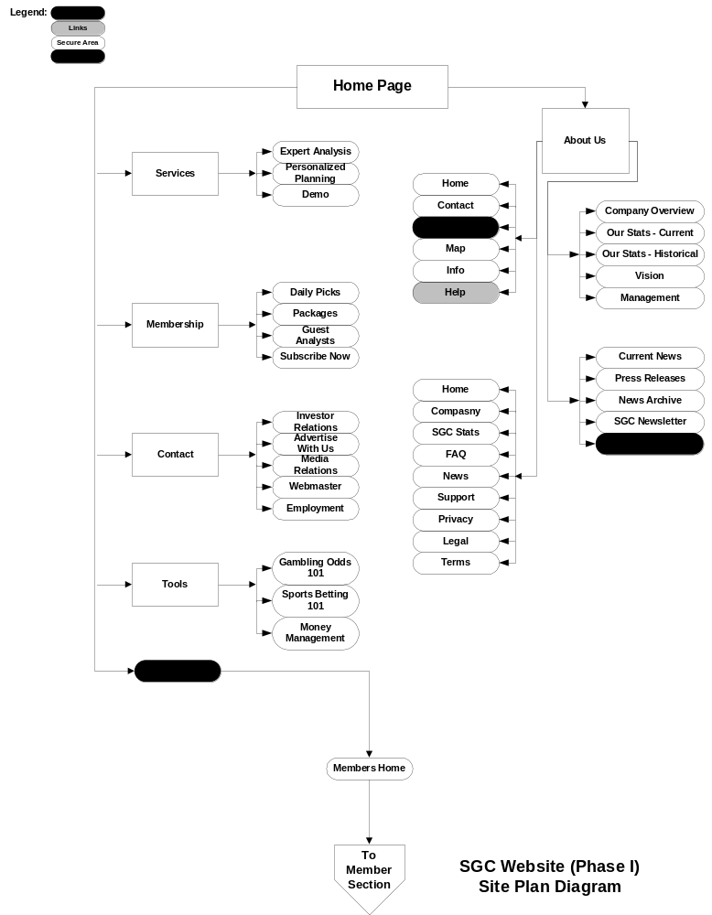

Figure 3-A.

“As Is” – Sportsteller Corporate Website Flow
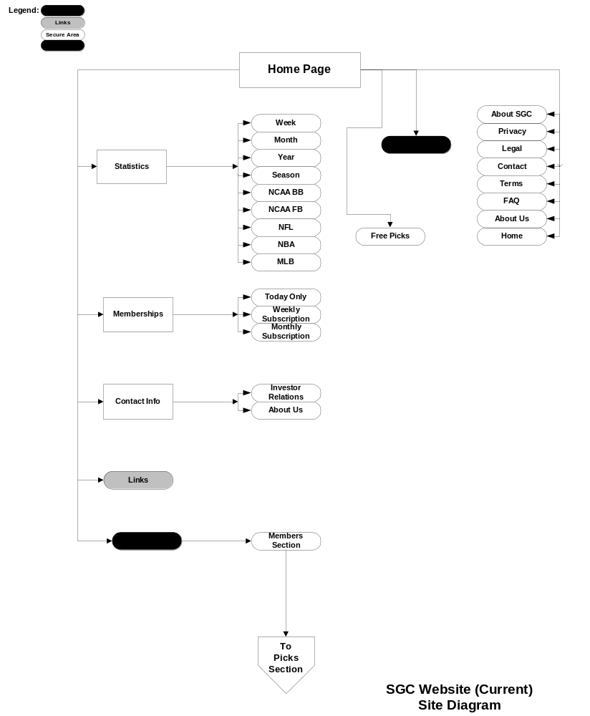

Figure 5-A.
“As Is” – Sportsteller Website Navigation

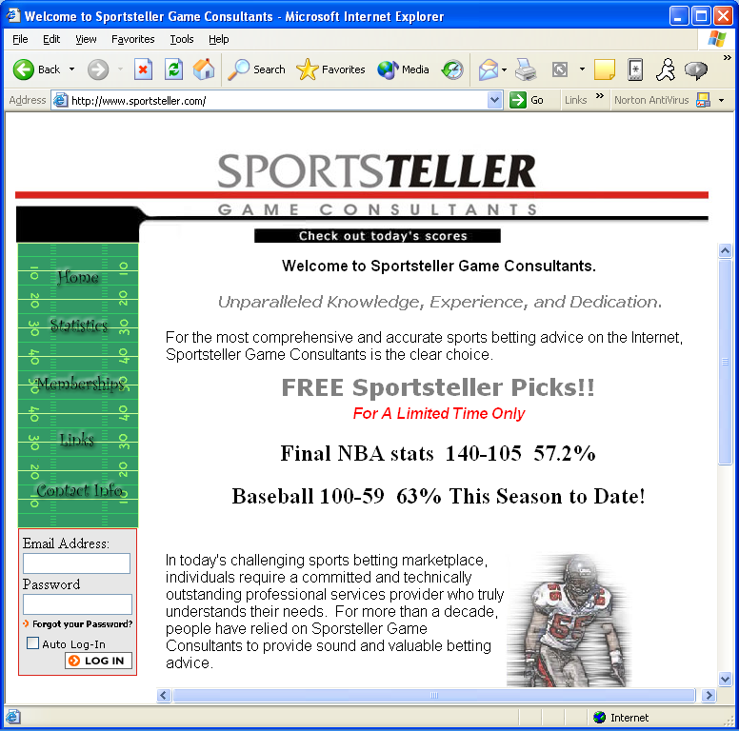

Figure 3-A.
“Could Be” – Sportsteller Website Navigation



